ASSESSMENT OF BANK EROSION VARIABILITY IN RIYADH CATCHMENT, AKKO LOCAL GOVERNMENT AREA, GOMBE STATE, NIGERIA
¹Sadeeq Abdulrasheed, ¹Didams Gideon, ¹Mary Adamu Baka ²Hauwa Abubakar
¹Department of Geography and Environmental Management Faculty of Sciences, Gombe State University, Nigeria
²Department of Science Education Faculty of Education, Gombe State University, Nigeria
Corresponding author’s email: sadeeqabdul360@gsu.edu.ng/ sadeeqabdul360@gmail.com
https//orcid.org/0000-0003-4186-4406

This study assessed how riverbank erosion varies across the Riyadh Catchment in Akko Local Government Area, Gombe State, Nigeria, and what factors are responsible for it. Both natural conditions and human activities were considered. Field data were collected from 19 cross-sections spaced about 300 meters apart along the river, while additional data came from satellite imagery, existing literature, and institutional sources. The analysis was carried out using QGIS and IBM SPSS. The findings show that over 90% of the catchment is underlain by the loose Keri-Keri Formation, making the riverbanks highly vulnerable to erosion. The area receives an average annual rainfall of about 800 mm. River discharge averages 5 m³/s but rises sharply to about 15 m³/s during the rainy season, increasing erosion intensity. Land use patterns reveal strong human influence: 57% of the land is urbanized, 27% is barren, 9% is farmland, 5% is covered by vegetation, and 2% consists of water bodies. Erosion rates vary along the river, with the lower reach experiencing the highest rate at 1.2 m/year, followed by the middle reach at 0.8 m/year, and the upper reach at 0.5 m/year. The river channel also becomes wider and deeper downstream. Overall, the study shows that erosion in the catchment is driven by a combination of fragile geology, seasonal increases in water flow, and intensive human activities, particularly urban expansion, highlighting the need for better land and watershed management.
Keywords: Bank Erosion, Variability, Cross-Profile, Riyadh Catchment, Gombe state.

- INTRODUCTION
Riverbank erosion is an inevitable natural phenomenon of any floodplain region. Bank erosion involves the mechanism of removal of bank materials from river banks by the fluvial actions like channel head pressure, velocity, discharge etc. The fluvial erosion takes place when the shear stress exceeds and the basal support is collapsed. Liquefaction of basal materials of a riverbank occurs when the effluent flow of ground water added into the river (Ghosh, 2019). Though the bank erosion is a natural and unimpeded phenomenon but it accelerates by anthropogenic interferences like changes of LULC over the time. The flood plains are the most endangered geomorphic units struggling against enhanced land use pressure (Tiwari, 2000; Chen et al 2023) Riverbank failure is the process which is leading to the fact of shifting of the river and the ultimatum is normally excessive river bank erosion and the erosion study from the environmental point of view always been designated as a hazardous situation for the local inhabitants though it has geared-up by some anthropogenic interferences (Rudra, 2010).
River cross section is a representation of the surface of the river that would be exposed if the relief feature or landform were cut through vertically at a point across the river’s channel and valley (Nimako, 2004; Mejia & Reed, 2011). Cross sections or profiles of rivers change in shape from the upper to the lower course which Mejia and Reed described as parabolic or triangular as a result of changes in the river’s energy in performing work and the processes that the river carries out (Jackson, 2015 and Wanah, 2017). Alabyan & Chalov (1998) looked at river channel patterns and their natural controls and evolved a morphological continuum, which they indicated was two-dimensional defined by plan features, which there were three: straight, meandering and branching. Their result also indicated that there were three structural levels of fluvial relief namely floodplain, flood channel and low-water channel. Their work was more qualitative than quantitative. Lack of measurement of stream channel parameters such as width and depth along the stream channel created a wide gap, which has to be addressed in order to make a statement on channel pattern. Observations of morphological plan on the surface may not be sufficient to permit making inferences on channel pattern. This study dwelt on measurement of depth and width of Riyadh River in order to define and characterize the morphological characteristics of the stream bank.
In studying river form and velocity, Waugh (1990) considered cross profiles of narrow and wide river channels and noted their influence on flow velocities. His work dwelled much on the hydraulics of stream flow and the volume of water the river discharges at a point, which he called hydraulic cross section of the river. His study did not considered situations in which rivers’ channel bed change in elevation, forming terraces on either side of the bank. At times, even the bed varies in depth, which, if not taken into account, may not give accurate volume of water being discharged at the point where quantification is being taken. Furthermore, resulting features such as channel depth, width, forms of bed and channel walls associated with the activity of rivers, and their implications on infrastructural development were not treated. The need for such studies cannot be overemphasized particularly when the rivers pass through or close to urban centers.
Oyegoke & Ifeadi (2007) applied Strahler’s system of stream ordering and investigated the relationship between drainage basin area and stream length to River Gongola. Having concentrated on drainage basin area and stream length, their work ignored the characteristics of the channel of river and thus their implications on structural developments such as agricultural, residential and transportation along and across the river in the light of the fact that river banks in Nigeria are inhabited by rapidly growing populations.
Bank erosion poses a significant threat to the Riyadh Catchment in the Akko Local Government Area of Gombe State, Nigeria. While this issue is recognized locally, a comprehensive analysis is lacking, hindering effective mitigation and management efforts. Therefore, the research problem is to assess the bank erosion variability in the Riyadh Catchment. Hence, the specific objectives of the study are to: identify factors contributing to bank erosion, quantify the extent of bank erosion and analyze cross-profile variability of bank erosion in the study area
2. MATERIALS AND METHOD
2.1 Study area
The study area is in Riyadh, Akko Local Government Area of Gombe State but due to the closeness of the area to the state capital, it is considered part of Gombe metropolis. It is located between Latitude 10° 14' 40” N to 10° 16' 52” N and Longitude 11° 06' 05'' E to 11° 12' 30'' E (Fig. 1). The study area consists of relatively low flat area lying between 440 m – 640 m above sea level. The area is made up of sedimentary rocks such as sandstone, which is underlain by crystalline complex rocks. These sedimentary formations of the late cretaceous have influenced topography of the area form a dissection and stream incision in the area which modified the landscape. Riyadh is geologically part of the Gongola basin, the exposure of non-marine Gombe sandstone a sequence of Albian coarse sandstone, occurs extensively in the study area. These are overlain recent tertiary Keri-Keri formation of estuarine origin comprising sandstone, siltstone and ironstone. The study area is within the groundwater province in the Gombe sandstone and Keri-Keri formation of the tertiary age (Ahmad & Wanah, 2023).
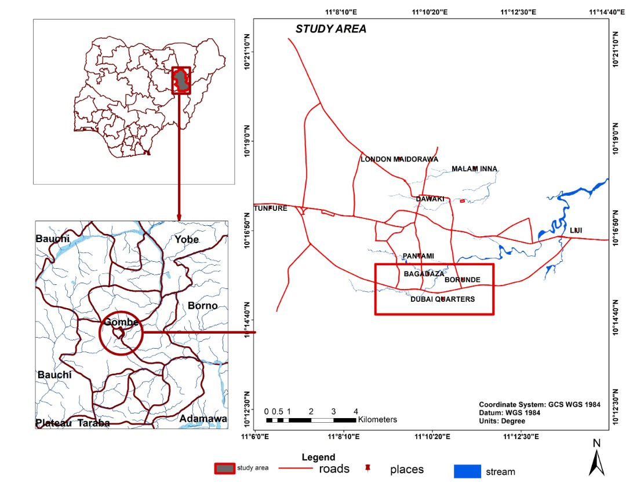
Figure 1: Study Area
Source; GIS Lab GSU, (2025)

2.2 Methods
In carrying out this study, both primary and secondary data were used. The Primary data were sourced from field observations, measurements, and questionnaires in the field. Whereas the secondary data were obtained from documented materials relevant to the study such as Journals, Text books, Publications, Unpublished materials, Federal ministry of land and Survey of Nigeria, United States Geological Survey (USGS) among others. A total of 19 points was taken at intervals of 300m along the length of the river channel for the production of cross sections. Where the channel was straight, the interval between two adjacent profiles was adjusted to more than 300m. On the other hand, where the stream channel meanders and therefore short stretches was encountered, the distance between two adjacent cross profiles was adjusted to less than 300m. The data collected were analyzed using QGIS and IBM SPSS statistical software. The results obtained were presented in tables and Maps.

3. RESULTS AND DISCUSSION

3.1 Factors Contributing to Bank Erosion and Cross Profile Changes in the Study Area

3.1.1 Geological Composition
The finding of this study revealed that the geological composition of the Riyadh Catchment predominantly consists of the unconsolidated Keri-Keri Formation, accounting for over (90%) of the geological makeup (Table 1), with the remaining (10%) percentage constituted by other formations such as Gombe Sandstone and Bima Shale. The prevalence of unconsolidated sedimentary rocks, particularly the Keri-Keri Formation, suggests a susceptibility to erosion due to their loose and easily transportable nature. Additionally, the presence of fault lines and the average fault density within the catchment were not specified, indicating a potential influence on bank erosion and cross-profile changes, although further investigation is required to ascertain their exact impact. The findings of this study are consistent with earlier geomorphological and hydrological research. The dominance of unconsolidated sedimentary formations (Keri-Keri Formation) and their high susceptibility to erosion align with the observations of Ghosh (2019), who emphasized that loosely consolidated alluvial materials are highly vulnerable to bank line migration under increased discharge conditions. Similarly, the relationship between peak discharge and intensified erosion in the lower reach supports the hydraulic principles discussed by Waugh (1990), who noted that velocity and discharge significantly influence channel widening and deepening.
3.1.2 Hydrological Factors
The study shows that Riyadh Catchment experiences an average annual rainfall of 800 mm (Table 1), contributing to the river discharge dynamics. The mean annual flow rate of 5m³/s indicates a relatively stable flow regime, while the peak flow rate during the raining season reaching 15m³/s suggests periods of increased water velocity and sediment transport potential. These hydrological characteristics play a significant role in shaping river morphology and erosion patterns, especially during high-flow, which can exacerbate bank erosion and cross-profile changes. The progressive downstream increase in channel width and depth observed in the Riyadh Catchment corresponds with classical fluvial geomorphology models described by Mejia and Reed (2011), who explained that channel cross-sections evolve longitudinally in response to energy distribution and sediment load. Furthermore, the morphological continuum observed in the study reflects the framework proposed by Alabyan & Chalov (1998), who classified river channel patterns based on structural and planimetric features.

3.1.3 Land Use
Regarding land use, the analysis revealed that the catchment exhibits a diverse distribution of land cover classes (Fig. 2). Barren land covers approximately (27%) of the area, likely offering little protection against erosion processes. The urbanized area, comprising (57%) of the catchment, poses a considerable risk as urbanization often leads to increased surface runoff and alteration of natural drainage patterns, consequently influencing erosion dynamics. Vegetation and farmland cover smaller proportions of the catchment (5% and 9% respectively), potentially providing some stabilization against erosion, although the intensity of agricultural activities and deforestation may counteract this effect. Water bodies, constituting 2% of the catchment, may contribute to erosion through channel incision or sediment deposition, depending on their morphology and flow dynamics.
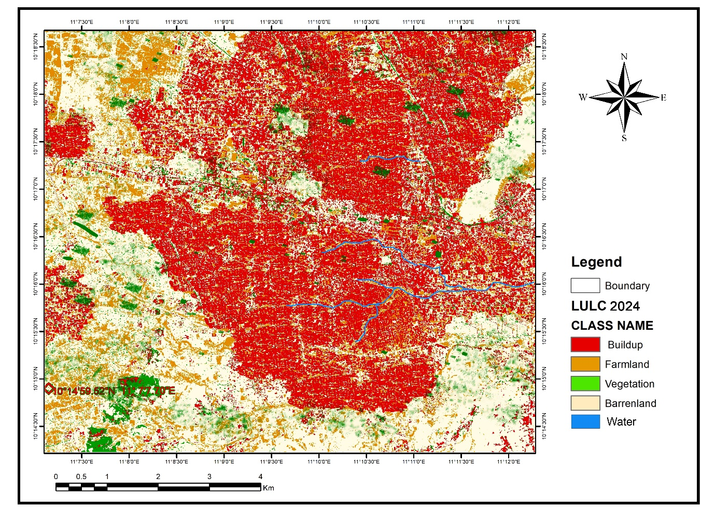
Figure 2: Land Use Classes of the study Area
Source: USGS Earth Explorer, (2025)
The influence of urban expansion (Fig. 2) (57% built-up area) and anthropogenic interference corroborates the findings of Tiwari (2000), who highlighted that land use change significantly accelerates erosion in developing regions. Likewise, the relationship between land use/land cover change and geomorphic instability agrees with the remote sensing-based findings of Chen et al. 2003.

3.1.4 Human Activities
The finding of this study revealed that Human activities within the catchment, including the presence of infrastructure, high levels of deforestation, moderate agricultural intensity, and annual urban expansion of 5% (Table 1), are significant contributors to bank erosion and cross-profile changes. Infrastructure development alters natural drainage patterns and increases impervious surfaces, leading to enhanced runoff and erosion. Deforestation reduces vegetation cover, diminishing soil stability and increasing erosion susceptibility. Agricultural activities often involve land clearing and soil disturbance, further exacerbating erosion processes. Urban expansion results in increased land surface modification, which can accelerate erosion rates through increased runoff and sediment transport.

3.1.5 Channel Morphology
The finding of this study (Fig. 2) shows that the channel morphology of the Riyadh Catchment exhibits varying slopes and widths along its course. The average longitudinal slope of 0.05 m/m indicates a relatively gentle gradient, while the steepest section slope of 0.1 m/m suggests areas of increased erosional potential. The range in channel width from a minimum of 10 meters to a maximum of 50 meters reflects spatial variability in flow dynamics and sediment transport capacity, influencing erosion rates and cross-profile changes along different stretches of the river.
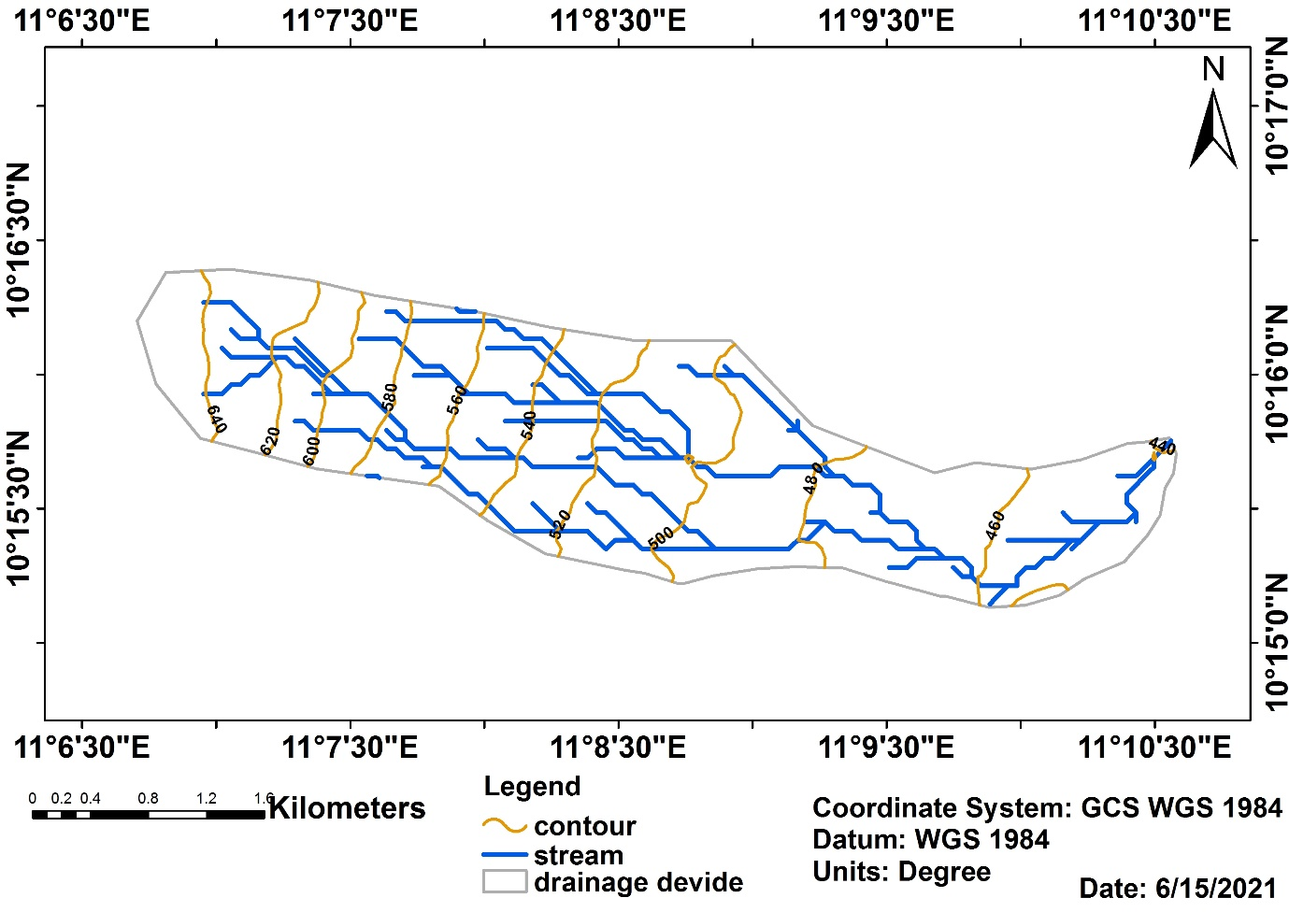
Figure 3: Riyadh River Basin
Source: USGS Earth Explorer, (2025).
At the national level, the spatial variability of erosion rates within the Riyadh Catchment is comparable to the work of Mbaya (2012), who documented increasing erosion intensity in Gombe urban environments due to rapid development and weak soil structure. The downstream intensification of erosion also supports the findings of Wanah (2017), who reported that morphometric characteristics and discharge variability significantly influence sediment transport and channel modification in Gombe drainage basins.
Overall, this study reinforces the broader consensus in fluvial geomorphology that bank erosion variability is the result of combined geological susceptibility, hydrological forcing, channel morphology, and anthropogenic disturbance.

Table: 1. Factors Contributing to Bank Erosion and Cross-Profile Changes in the Study Area.
Factor | Description
Geological Factors  Geological Composition | Unconsolidated Keri-Keri Formation: >90%  Other formations (Gombe Sandstone, Bima Shale, etc.): <10%
Hydrological Factors  Average Annual Rainfall  Discharge | 800 mm River Mean annual flow rate: 5 m³/s  Peak flow rate during monsoon: 15 m³/s
Land Use Classes | Barren land 27% Buildup (urbanized area) 57%  Vegetation 5% Farmland 9% Water bodies 2%
Human Activities | Presence of infrastructure Yes  Intensity of deforestation High Intensity of agricultural activities Moderate Urban expansion rate 5% annually
Channel Morphology  Channel Slope  Channel Width | Average longitudinal slope 0.05 m/m  Steepest section slope 0.1 m/m  Flattest section slope 0.02 m/m  Mean channel width 20 meters  Maximum channel width 50 meters  Minimum channel width 10 meters
Source: Field Work, 2025

3.2 The Extent of Bank Erosion along Different Stretches of the Riyadh Catchment
The Study reveals distinct patterns of bank erosion rates across various river stretches (Table 2). In the upper reach, characterized by a length of 15km, the average bank erosion rate is recorded at 0.5 meters per year. Although this represents a relatively lower erosion rate compared to the other reaches, it is still indicative of ongoing erosion processes. The maximum erosion rate observed in this segment is 1.2 meters per year, suggesting localized areas of higher erosion intensity, potentially influenced by specific geomorphic features or anthropogenic activities. Conversely, the minimum erosion rate of 0.3 meters per year signifies areas with comparatively lower erosion susceptibility or effective erosion control measures.
Moving to the middle reach of the catchment, spanning 20km in length, a higher average bank erosion rate of 0.8 meters per year is observed. This indicates increased erosion activity within this segment, possibly attributed to factors such as channel morphology, hydrological dynamics, or land use practices. The maximum erosion rate in the middle reach reaches 1.5 meters per year, signifying areas of heightened erosion vulnerability or localized erosional hotspots. Conversely, the minimum erosion rate of 0.4 meters per year suggests areas with relatively lower erosion intensity or more stable bank conditions.
In the lower reach, covering a distance of 25km, the study illustrates the highest average bank erosion rate among the three segments, recorded at 1.2 meters per year. This indicates a notable degree of erosion activity within this reach, potentially influenced by factors such as increased channel dynamics, sediment transport, or anthropogenic pressures. The maximum erosion rate observed in the lower reach is 2.0 meters per year, highlighting areas of pronounced erosion susceptibility or significant erosional processes. However, the minimum erosion rate of 0.6 meters per year suggests spatial variability in erosion intensity, with some areas exhibiting relatively lower erosion rates compared to others.
Table 2: the Extent of Bank Erosion
River Stretch | Length (Km) | Average Bank Erosion (m/year) | Maximum Bank Erosion (m/year) | Minimum Bank Erosion (m/year)
Upper Reach | 15 | 0.5 | 1.2 | 0.3
MiddleReach | 20 | 0.8 | 1.5 | 0.4
Lower Reach | 25 | 1.2 | 2.0 | 0.6
Source: Field Work, 2025

3.4 The cross-profile variability of the river channel within the Riyadh Catchment

3.4.1 Lower Reach of the Catchment
The study shows that in the lower reach of the catchment (Table 3), it is characterized by relatively lower elevations, the cross-sections exhibit wider channel widths and deeper depths compared to the middle and upper reaches. For instance, at CS-1 in the lower reach, the channel width is 25 meters with a depth of 2 meters, while at CS-4, the channel width increases to 40 meters with a depth of 3.5 meters. These observations suggest a wider and deeper river channel in the lower reaches, likely influenced by increased discharge and sediment transport capacity downstream.
Table 3: Lower Reach of the Catchment
Cross-section ID | Channel Width (m) | Channel Depth (m) | Bank full Width (m) | Bank full Depth (m) | Slope (%) | Coordinates  (Lat, Long) | Elevation (m)
CS – 1 | 25 | 2 | 30 | 3 | 0.03 | 10°15'52''N, 11°10'41''E | 427.07
CS – 2 | 30 | 2.5 | 35 | 3.5 | 0.04 | 10°15'47''N, 11°10'41''E | 428.66
CS – 3 | 35 | 3 | 40 | 4 | 0.05 | 10°15'43''N, 11°10'31''E | 429.8
CS – 4 | 40 | 3.5 | 45 | 4.5 | 0.06 | 10°15'41''N, 11°10'32''E | 431.62
Source: Field Work, 2025

3.4.2 Middle Reach of the Catchment
The result revealed that in the middle reach (Table 4), the cross-sectional data shows intermediate channel morphologies compared to the lower and upper reaches. Channel widths and depths are generally narrower and shallower than those in the lower reach but wider and deeper than those in the upper reach. For instance, at CS-5 in the middle reach, the channel width is 20 meters with a depth of 1.5 meters, indicating a narrower and shallower channel compared to the lower reach. However, the channel width and depth increase gradually downstream, as seen at CS-8, with a width of 35 meters and a depth of 3 meters, reflecting a transition towards the wider and deeper characteristics of the lower reach. This finding supports the findings of Wanah (2017), who reported that morphometric characteristics and discharge variability significantly influence sediment transport and channel modification in Gombe drainage basins.

Table 4: Middle Reach of the Catchment
Cross-section ID | Channel Width (m) | Channel Depth (m) | Bank full Width (m) | Bank full Depth (m) | Slope (%) | Coordinates  (Lat, Long) | Elevation (m)
CS – 5 | 20 | 1.5 | 25 | 2 | 0.02 | 10°15'39''N, 11°10'27''E | 432.79
CS – 6 | 25 | 2 | 30 | 2.5 | 0.03 | 10°15'34''N, 11°10'25''E | 436.9
CS – 7 | 30 | 2.5 | 40 | 3.5 | 0.04 | 10°15'27''N, 11°10'22''E | 437.36
CS – 8 | 35 | 3 | 40 | 3.5 | 0.05 | 10°15'29''N, 11°10'12''E | 439.29
Source: Field Work, 2025

3.4.3 Upper Reach of the Catchment
In the upper reach of the catchment (Table 5), the finding shows a characterized higher elevation, the cross-sectional data depicts narrower and shallower channel dimensions compared to the middle and lower reaches. Channel widths and depths are generally smaller, reflecting a narrower and more confined river channel in the upper reaches. For example, at CS-9 in the upper reach, the channel width is 15 meters with a depth of 1 meter, indicating a relatively narrow and shallow channel compared to the lower and middle reaches. However, the channel width and depth gradually increase downstream, as observed at CS-12, with a width of 30 meters and a depth of 2.5 meters, indicating a transition towards the wider and deeper characteristics of the middle and lower reaches.

Table 5: Upper Reach of the Catchment
Cross-section ID | Channel Width (m) | Channel Depth (m) | Bank full Width (m) | Bank full Depth (m) | Slope (%) | Coordinates  (Lat, Long) | Elevation (m)
CS – 9 | 15 | 1 | 40 | 1.5 | 0.01 | 10°15'16''N, 11°10'07''E | 443.02
CS – 10 | 20 | 1.5 | 25 | 2 | 0.02 | 10°15'12''N, 11°10'00''E | 446.20
CS – 11 | 25 | 3 | 30 | 2.5 | 0.03 | 10°15'12''N, 11°09'14''E | 449.64
CS – 12 | 30 | 2.5 | 35 | 3 | 0.04 | 10°15'17''N, 11°09'43''E | 455.47
Source: Field Work, 2025

4. CONCLUSION
The research undertaken to assess bank erosion and cross-profile variability within the Riyadh Catchment, situated in Akko Local Government Area, Gombe State, provides a comprehensive understanding of the factors influencing erosion dynamics and channel morphology in the region. The geological analysis underscores the predominance of sedimentary rocks, particularly the unconsolidated Keri-Keri Formation, which contributes to erosion susceptibility within the catchment. Hydrological characteristics, such as average annual rainfall and peak flow rates, alongside human activities like urbanization, deforestation, and agricultural practices, further exacerbate erosion processes.
Quantification of bank erosion rates across different segments of the catchment highlights spatial variability, with the lower reach exhibiting higher erosion rates compared to the middle and upper reaches. Cross-profile variability analysis reveals distinct morphological characteristics along the river course, with wider and deeper channels observed in the lower reach and narrower, shallower channels in the upper reach. The middle reach demonstrates intermediate channel morphologies.
Comparisons with previous research align findings, indicating the influence of geological characteristics, anthropogenic activities, and channel confinement on erosion dynamics and channel morphology. Studies underscore the importance of localized research to inform erosion management strategies tailored to specific catchment characteristics.
The research contributes valuable insights into erosion processes and channel morphology within the Riyadh Catchment, providing a foundation for informed decision-making in watershed management and erosion control efforts. By recognizing the spatial variability and underlying factors driving erosion dynamics, stakeholders can develop targeted strategies to mitigate erosion impacts and sustainably manage water resources within the catchment, ensuring the resilience of the local ecosystem and communities against erosion-related challenges.

RECOMMENDATIONS
Based on the findings of this study, the following recommendations were made:
Implement erosion control measures, such as vegetative buffer strips and erosion-resistant materials, along vulnerable riverbanks to mitigate the impact of sediment transport and stabilize channel morphology. Introduce sustainable land use practices, including reforestation and soil conservation techniques, to reduce erosion rates and preserve soil integrity within the catchment area. Conduct regular monitoring and assessment of channel morphology and erosion dynamics to identify evolving trends and prioritize targeted interventions in erosion-prone areas. Foster community engagement and awareness campaigns to promote responsible land management practices and minimize anthropogenic contributions to erosion within the catchment. Enhance collaboration among stakeholders, including government agencies, local communities, and environmental organizations, to develop integrated watershed management plans aimed at mitigating erosion and preserving water quality. And Invest in research and innovation to explore alternative erosion control methods, such as bioengineering solutions and sustainable riverbank stabilization techniques, to complement traditional approaches and enhance long-term erosion management strategies.
REFERENCES
Ahmad, A., & Wanah, B. B. (2023). Groundwater occurrence in the Gombe Sandstone and Keri- Keri Formation, northeastern Nigeria. Journal of Environmental Hydrology, 31(2), 45–59.
Alabyan, A. M., & Chalov, R. S. (1998). Types of river channel patterns and their natural controls. Earth Surface Processes and Landforms, 23(5), 467–474. https://doi.org/10.1002/(SICI)1096-9837(199805)23:5<467::AID-ESP861>3.0.CO;2-O
Benkhelil, J., Guiraud, M., Ponsard, J. F., & Saugy, L. (1989). The Bornu–Benue Trough, the Niger Delta and its offshore: Tectono-sedimentary reconstruction during the Cretaceous and Tertiary. In C. A. Kogbe (Ed.), Geology of Nigeria (pp. 278–319). Rock View Nigeria Limited.
Chen, J., Gong, P., He, C., Pu, R., & Shi, P. (2003). Land-use/land-cover change detection using improved change-vector analysis. Photogrammetric Engineering & Remote Sensing, 69(4), 369–379.
De Blij, H. J., Muller, P. O., Williams, R. S., Conrad, C. T., & Long, P. (2005). Physical geography: The global environment (Canadian ed.). Oxford University Press.
Faniran, A., & Jeje, L. K. (2002). Humid tropical geomorphology. Heinemann Educational Books.
Ghosh, D., & Sahu, A. S. (2019). Bank line migration and its impact on land use and land cover change in dynamic river systems. Journal of the Indian Society of Remote Sensing, 47(12), 1969–1988. https://doi.org/10.1007/s12524-019-01058-4
Jackson, A. (2015). Changing long and cross profiles along a river. Cool Geography. Retrieved from https://www.coolgeography.co.uk
Mbaya, L. A. (2012). An assessment of gully erosion in Gombe Town, Gombe State, Nigeria (Doctoral thesis, University of Maiduguri, Nigeria).
Mejia, A. I., & Reed, S. M. (2011). Role of channel and floodplain cross-section geometry in basin response. Water Resources Research, 47(9), W09506. https://doi.org/10.1029/2010WR009825
Oyegoke, S. O., & Ifeadi, C. (2007). Relationship between drainage basin area and stream length for River Gongola, Nigeria. The Pacific Journal of Science and Technology, 8(2), 184– 189.
Rudra, K. (2010). Dynamics of the Ganga in West Bengal (1764–2007). Quaternary International, 227(2), 161–169. https://doi.org/10.1016/j.quaint.2009.11.016
Tiwari, P. C. (2000). Land-use changes in Himalaya and their impact on the plains ecosystem: Need for sustainable land use. Land Use Policy, 17(2), 101–111. https://doi.org/10.1016/S0264-8377(00)00002-8
Wanah, B. B. (2017). Analysis of morphometric properties and sediment discharge of Bagadaza drainage basin, Gombe State, Nigeria (Doctoral thesis, University of Maiduguri, Nigeria).
Wanah, B. B., & Abdullahi, J. (2018). Analysis of longitudinal profile of Bagadaza River in Akko LGA, Gombe State, Nigeria. Journal of Environmental Sciences and Policy Evaluation, 8(4), 1–24.
Waugh, D. (1990). Geography: An integrated approach. Nelson.
Zhang, Q., Shi, Y., & Xiong, M. (2020). Geometric properties of river cross sections and associated hydrodynamic implications in the Wuhan–Jiujiang River reach of the Yangtze River. Environmental Earth Sciences, 79, 1–15. https://doi.org/10.1007/s12665-020- 08933-

